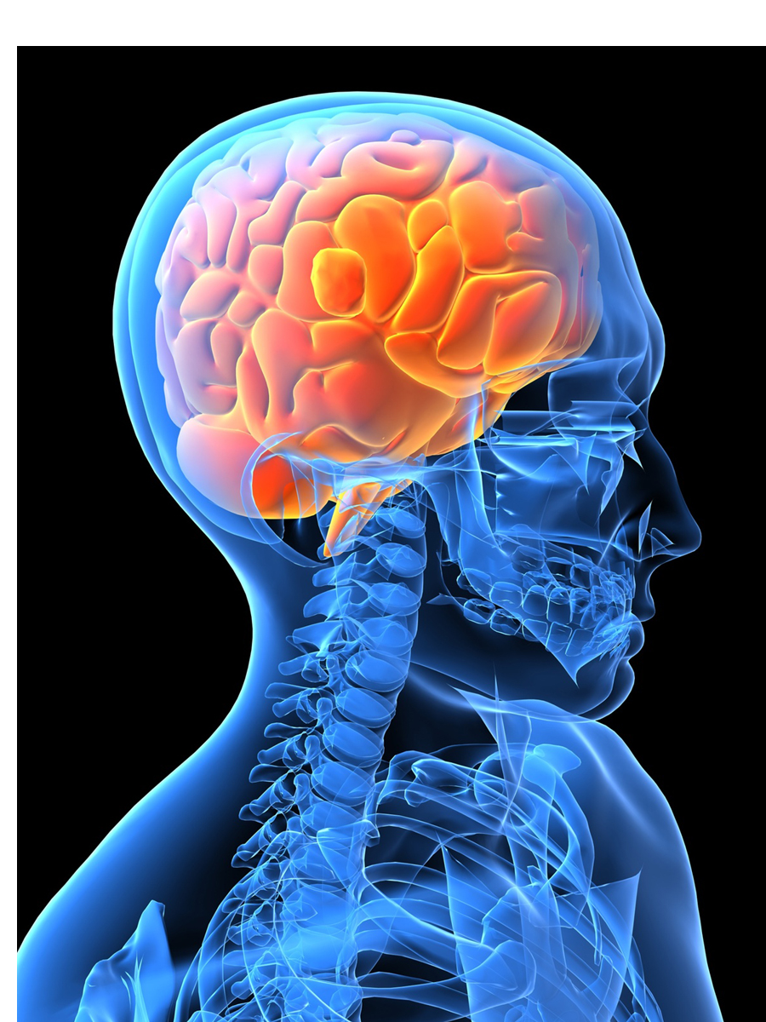
Medical Imaging: Pattern Recognition
CSE 5870
(Cross-listed with, Medical Imaging: BME 5259)

Instructor: Debasis Mitra, Ph.D.
E-mail: dmitra@cs.fit.edu, Office: Harris 325
Time: Fall 2012, Monday-Wednesday 8-9:45pm
Class Home Page: http://www.cs.fit.edu/~dmitra/MedImage/
Please follow the table for activities: cs.fit.edu/~dmitra/12Spr/TabularSylSpr12SciComp.doc
Office Hours: TBD

Text: Jerry Prince & Jonathan M. Links, “Medical Imaging: Signal & Systems,” Pearson Prentice Hall, 2006, ISBN 0-13-065353-5.

Other basic reference materials: to be added

FIT Catalog Course Description (CSE 5870):
Introduces the fundamentals of statistical pattern recognition with examples from different biomedical application areas. Studies techniques for analyzing multidimensional data of various types and scales. Also covers algorithms for projections, clustering and classification of data.

Course Objective:
The course will have mostly student presentations and discussion, possibly followed by quizzes & projects. We will go over some chapters from the text for basic knowledge on the medical imaging area. We will do some research level works with medical image data, implement some standard algorithms in the area, and do some specialized self-study.

Prerequisites:
This is a specialized course. Some background in Algorithms and Data Structures are needed for any CS students. Non-CS students should have computing experience, even at Matlab® level. Strong mathematical sense and some knowledge in Physics may be helpful.

Lecture Topics:
See the “plan” (.doc) from class web page: http://www.cs.fit.edu/~dmitra/MedImage/

Grading (tentative):
Mostly on projects, class presentations/discussions, & possibly some quizzes.

Standard Class Policy:
Copying, plagiarizing and unauthorized collaboration on assignments will be considered as cheating, which may lead to a ‘F’ grade in the class, and other disciplinary actions subject to the University regulations. Any question about the graded class materials should be raised within the two class periods after the graded material is returned to the students. Examinations are announced normally one week prior to the exam date. No make up tests will be given. Students may be asked to attend lectures outside the normal class schedule. Physically challenged students needing any special assistance should consult the instructor. University policy allows a student to be absent from the class on any special religious day for the respective student, provided the instructor is informed at the beginning of the semester.

